Records Management Framework
RISK AND INFORMATION SERVICES
Records Management Framework

Preamble
The Royal Children’s Hospital (RCH) records management framework has been developed in line with the Public Records Office of Victoria (PROV) standards. Several frameworks have been investigated including the National Archives of Australia (NAA) Information Governance Framework, the Information Management Framework for the Victorian Public Service and the New South Wales Information Governance Framework. The Australian Standards AS ISO 15489 Information and documentation - Records management - Concepts and principles has also been considered in the development of this framework.

Scope
The framework is a broad over-arching document that incorporates administrative records, medical and research records. Each of these record categories are governed by separate procedures and management processes.

Records Management Framework
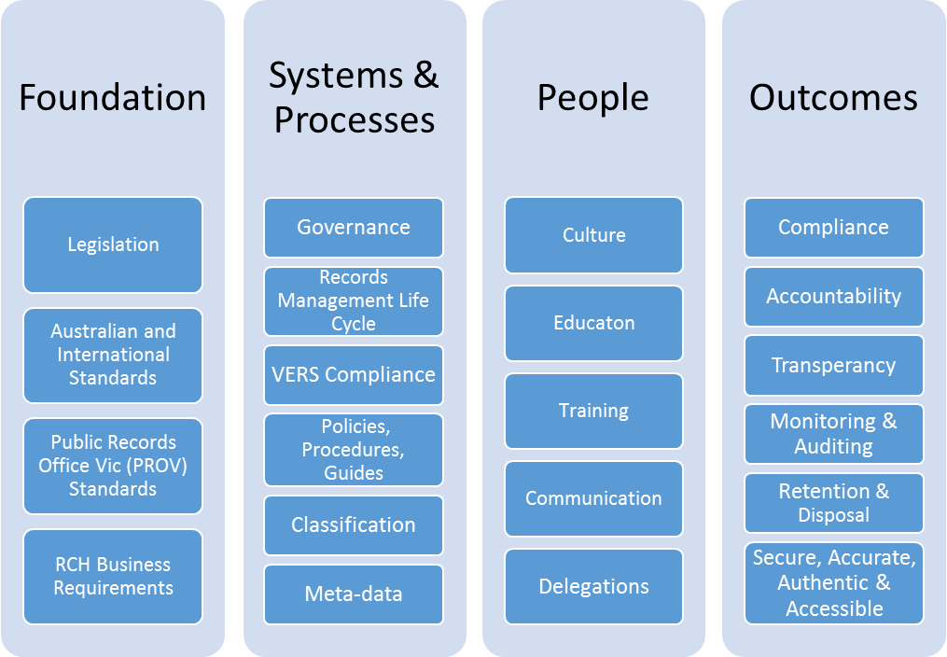
The following high level framework has been developed to support the Royal Children’s Hospital (RCH) to fulfil its recordkeeping obligations, ensure that a multilayered organisation wide approach is taken and to establish an over-arching structure for effective records management. Records management is complex and incorporates many factors including foundation elements, systems, processes, people and outcomes. Records management is a key component of information management. The records management framework ensures that key requirements, standards and business operations are met. Information is managed and treated as an asset applying the Public Records Office of Victoria (PROV) principles of creation, capture, strategic management, operational management, storage and disposal. The framework has been endorsed by the Administrative Records Management Committee.

Definitions

Records: (AS ISO 15489.1:2017): Information created, received and maintained as evidence and as an asset by an organisation or person, in pursuit of legal obligations or in the transaction of business.

Administrative Record: Information created, received and maintained as evidence relating to common administrative functions. This includes but is not limited to financial, human resources, information technology, public statements and presentations, legal services and contract management.

Medical Record: a manual or electronic record containing a patient's health and personal information, status and treatment. Also referred to as a patient file and patient history.

Research Record: Documents which individually and collectively permit the evaluation of the conduct of the study and the quality of the data produced.

Public Records Office of Victoria (PROV): is the archive of the State Government of Victoria.

Records Management Lifecycle: (PROV): Involves the management of records from the point of creation through to the capture, long-term storage, appraisal and disposal or transfer to the Public Records Office.

Appraisal: (AS 4390-1996, Part 1, 4.3): The process of evaluating business activities to determine which records need to be captured and how long the records need to be kept, to meet business needs, the requirements of organisational accountability and community expectations.

Destruction (AS ISO 15489.1-2002, s3.8): process of eliminating or deleting records, beyond any possible reconstruction.

Disposal (PROV): A range of processes associated with implementing appraisal decisions which are documented in disposal authorities or other instruments. These include the retention, destruction or deletion of records in or from recordkeeping systems. They may also include the migration or transmission of records between recordkeeping systems, the transfer of ownership or the transfer of custody of records, e.g. to Public Record Office Victoria

VERS Compliance: (PROV): The Victorian Electronic Records Strategy (VERS) has been developed by PROV to ensure the creation, capture and preservation of authentic, complete and meaningful digital records by the Victorian public sector. Records of continuing value must remain accessible for as long as they are required. PROV has developed a long-term format called a VERS Encapsulated Object (VEO) for the preservation of digital records. Permanent value digital records (as well as some long-term temporary records) should be converted into VEOs.
Meta-data: (AS ISO 15489.1:2017): Structured or semi structured information, which enables the creation, management, and use of records through time and within and across domains.

Classification: (AS ISO 15489.1:2017): Systematic identification and/or arrangement of business activities and/or records into categories according to logically structured conventions, methods and procedural rules.

Foundation:
The RCH operates within several standards and legislative requirements. A solid framework ensures that recordkeeping practices and standards are followed and maintained across RCH. In this context the RCH is governed by the following legislation and standards:
- Public Records Act (Vic) 1973
- Freedom of Information Act (Vic) 1982
- Health Records Act (Vic) 2001
- Crimes Document Destruction Act (Vic) 2006
- Evidence Act (Vic) 2008
- Electronic Transactions (Vic) Act 2011
- Privacy and Data Protection Act (Vic) 2014
- AS ISO 15489 Information and documentation - Records management - Concepts and principles
- Epidemiological Studies (Confidentiality) Act 1981 (Cth)
- Health Services Act 1988 (2014)
- Mental Health Act 2014
- Australian Research Council Act 2001 (Cth)
- Gene Technology Act 2000 (Cth)
- Gene Technology Act 2001 (Vic)
- Gene Technology Regulations 2001 (Cth)
- Guardianship and Administration Act 1986 (Vic)
- Human Tissues Act 1982 (Vic)
- Privacy Act 1988 (Cth)
- Therapeutic Goods Act (1989) (Cth)
- Therapeutic Goods Regulations 1990
- National Health and Medical Research Council Act 1992, which includes compliance with;
- National Statement on Ethical Conduct in Human Research (2007 updated 2018)
- Australian Code for the Responsible Conduct of Research (2018)
- Integrated Addendum to ICH E6(R1): Guideline for Good Clinical Practice ICH E6(R2)
The framework establishes the basis for the way in which records and information is managed across RCH and how various types of information will support the work carried out and meet significant business requirements.

Systems and Processes:
In order to achieve and maintain legislative requirements and standards, clear governance, processes, business rules, policies, procedures and systems are essential to allow for effective records management. Governance will be achieved through committee oversight and monitoring. Metadata is a key component providing the context, content and structure of a record and contributes to the authenticity and reliability over time. Technology and systems used to capture and maintain records will allow for the management of their entire lifecycle. Systems will support the authoritativeness of records by meeting the principles of reliability, security, classification, compliance and comprehensiveness (AS ISO 15489.1:2017). Processes and systems enable the protection of information, help to reduce inefficiencies, and encourage information sharing and collaboration across departments. The lifecycle of records takes into account the management of information over time, legal and business retention requirements as well as preservation and disposal. The Victorian Electronic Records Strategy (VERS) is in alignment with this component and also focuses on information being captured and retained for the length of time required for business, evidential and information purposes and only destroyed when authorised.

People:
Staff across RCH have a significant role in the management and care of records. People enable and contribute to a culture that promotes effective information management. A communication program will ensure that the profile of records management is raised and opportunities for collaboration between departments and teams is encouraged. Ongoing training and education covering specific record type’s and best practice will be implemented where relevant and will also contribute to the ongoing learning and development of staff with key records management responsibilities and delegations.

Outcomes:
The RCH records management framework will allow for a standard approach to managing information and records over their entire life-cycle. Key outcomes of the framework will include meeting legislative requirements as well as ongoing monitoring and reporting processes to ensure that records management policies and structures are reviewed and adequately maintained. Continued monitoring will also allow for policies, procedures and processes to remain up-to date and adapt to relevant changes to legislation and standards over time. The establishment of consistent practices will increase evidence based decision-making, accountability and transparency across the organisation.

Summary:
The framework will support the Royal Children’s Hospital (RCH) to fulfil its recordkeeping obligations and provide a broad structure for the management of records over time. The framework is part of a suite of documents that will contribute to an effective program to increase the records and information capability of RCH.
For further information please refer to relevant policies and procedures including:

Information Management Policy (pending link to web page to be inserted)
Administrative Records Management (pending link to web page to be inserted)
Health information Services
Research
Legislative Compliance
Communications and Marketing
Intellectual Property
Governance
Information and Communications Technology

