Exit Site Care
Tenckhoff Exit Site:
- The Tenckhoff exit site must be kept dry and clean at all times
A moist exit site creates granulomas and increases the risk of infection
- The exit site must be changed immediately after every bath or shower
- The dressing should be changed every 2-5days depending on age
More frequent changes may be necessary when infection is present
- If the exit looks moist, oozy or red notify the PD co-ordinator or nephrologist on-call immediately
- Mupirocin (bactroban) cream or medi-honey wound gel may be required
- In cases where a granulona is present silver nitrate may be required to burn the granuloma

Bath Dressing:
- Before the bath, coil the catheter over the existing dressing and cover with tegaderm to minimize water entry
- Bath as normal
- After the bath remove the tegaderm along with the existing dressing
- Clean with normal saline, dry and redress with supplied dressing

Shower Dressing:
- Secure Tenckhoff around waist with elastic or tape
- Remove dressing (before shower or under running water if preferred)
- Shower as normal with antibacterial soap
- Step out of shower and immediately dry exit site with sterile gauze
- Apply supplied dressing and secure Tenckhoff as desired

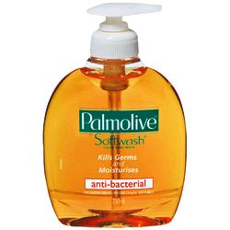
Palmolive Antibacterial Soft Wash
Sold as a hand wash not body wash
Preferred soap option for Shower dressing
Use when not waterproofing dressing prior to bathing
Never refill pump bottle due to infection control

