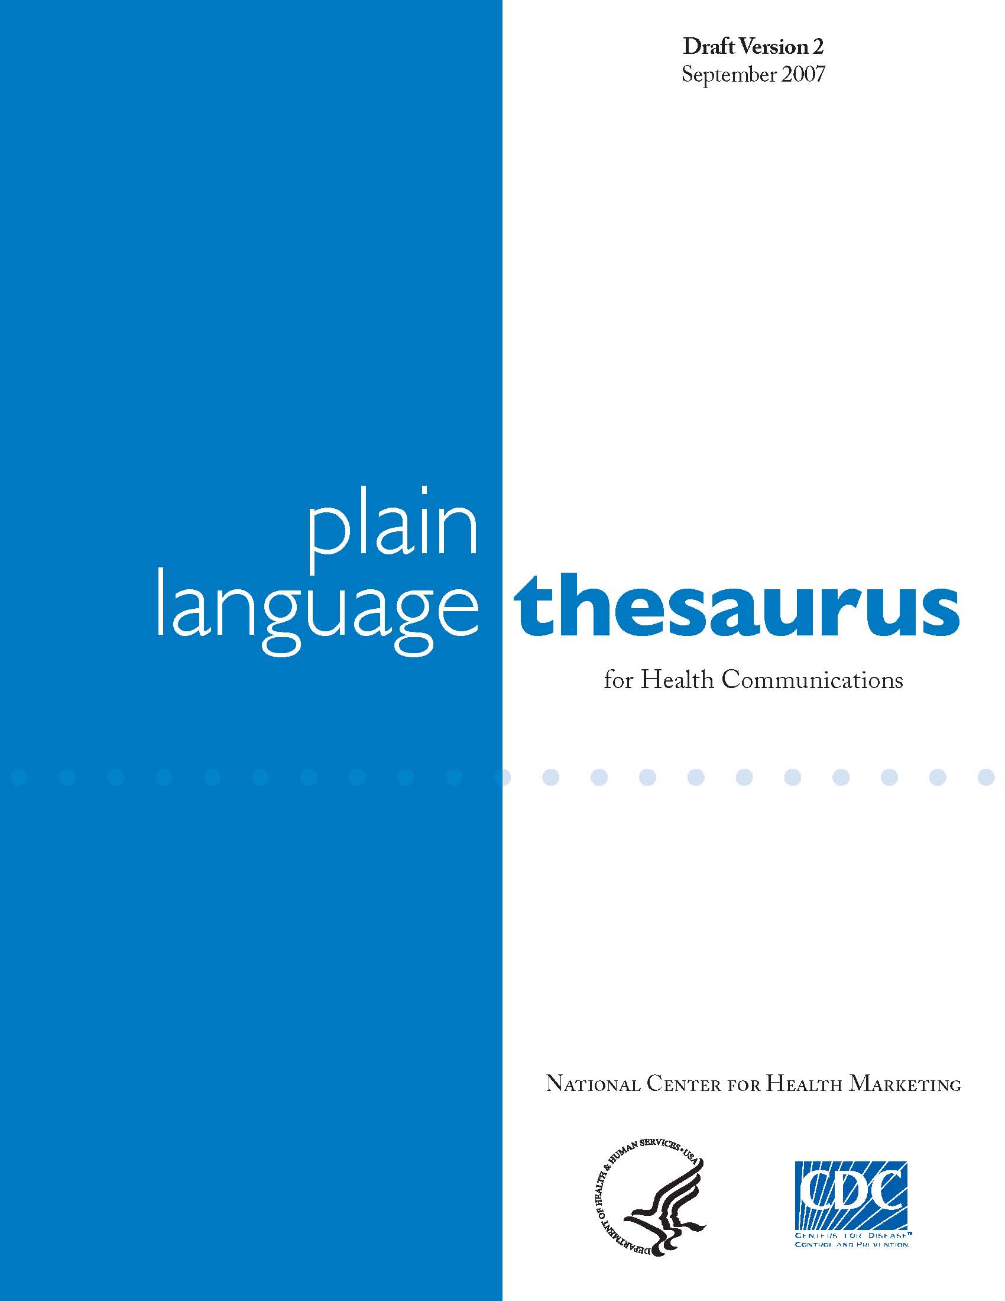
February 2009

Plain Language Thesaurus
For Health Communications
This Plain Language Thesaurus has been put together by the Centers for Disease Control and Prevention’s National Center for Health Marketing. Our aim is to help make health information clear and easy to understand.
This thesaurus offers plain language equivalents to medical terms, phrases, and references that we often use. The technical terms found in health information can be confusing. This thesaurus is a tool to help you find words that people may understand better.
While the plain language choices given here may not have the specific nuances of meaning that technical terms have, they offer the possibility for better understanding by your audience. With plain language equivalents, it is more important to be understood than to be medically precise.
Precise medical terminology is vital when communicating to those with a technical background. But the public often stumbles over such terms and misunderstands their meaning. This is especially a concern for people who do not speak English as their first language and those without strong reading skills. Reaching your audience–on their terms–is the main goal of plain language.
This is a living document. It is intended to be refined and to grow as more health communicators and experts add words, topics, health conditions, and synonyms. We have started the process of building this tool by defining the scope, format, and broad categories of terms to be included. Excellent existing resources and glossaries from CDC, HHS, universities were reviewed for terms and subject areas. Key sources included
- www.pandemicflu.gov glossary
- CDC Community Strategy for Pandemic Influenza Mitigation glossary
- National Immunization Program Glossary http://www.cdc.gov/vaccines/about/terms/glossary.htm
- Simple Words and Phrases thesaurus at plainlanguage.gov
- Clear Language and Design (CLAD) thesaurus http://www.eastendliteracy.on.ca/ClearLanguageAndDesign/thesaurus/
- Harvard’s three Plain Language Glossaries (one for asthma, lupus, and arthritis).

The foundation for the terms in this initial edition was formed when preparing information for the public health threats of an influenza pandemic. We have also included other categories of disease and health conditions to provide a tool that can be referenced to make any health topic more easily understandable.
We invite you to suggest additional terms, plain language synonyms, and topics to be added in future editions. For more information, please contact Sarah Gregory at CDC by email at sgg7@CDC.GOV.

A
abscess
sore, wound, infection

abdomen
stomach, stomach area, belly, tummy, abdominal

ability
skill, are able, can

abolish
end, do away with, get rid of

abrasion
cut, scratch, scrape

absenteeism
missing work or school, how often you miss work or school

absorption
take in, soak up

accelerate
hurry, speed up, make worse, make more severe

accessible
available, on hand, understandable, usable (handicapped)

accommodate
house, let stay with, give shelter, adjust, adapt

accompany
go with, take with (medicine)

accomplish
do, finish

accumulate
add up, gather, collect

accurate
true, right, correct

acellular vaccine
a vaccine that only contains part of the virus

Acquired Immune Deficiency Syndrome-AIDS
a disease that makes it hard for your body to fight diseases

active immunity
being able to fight off a specific disease once you have had that disease

acute
sudden start, short term, quick

additional
extra, added, more

adequate
enough, the right amount

adhere
stick, follow

adjacent
beside, next to, near, touching

adjuvant
something added to a vaccine to make it work better

administer
give, manage, take care of

adverse event
something bad that happens, bad reaction, unexpected or unwanted effects

adverse health effect
bad side effect, bad reaction

adverse
bad, dangerous, hurtful, harmful

advise
tell, warn, say

advocacy
support, fighting on behalf of, arguing for support

advocate
fight for, support, support person

aerobic exercise
exercise; slow and steady exercise like walking, running, biking, swimming, etc.; exercise that helps your heart stay healthy and work better; exercise that gets your heart pumping; exercise that makes you breath faster

aerobic
needs oxygen

aerosol
spray, mist

agency
others, other groups, partner

aggravate
make worse, harm, anger, hurt

aggregate
taken together, looked at all together, total, sum, combined

aggressive
pushy, dangerous, gets worse fast, fast growing

airways
windpipe, breathing, tubes that take air in from the nose and mouth to the lungs,
pathway from nose and mouth to lungs, air tubes

alienate
push away, put by itself, turn away from, set apart

allergen
something like pollen that causes the body to react by sneezing or forming a rash; something that causes an allergic reaction

allergic
the body’s reaction to something, like pollen, resulting in sneezing, sniffling, a rash, etc.

allergic reaction
bad reaction, possibly deadly reaction, allergy, problem

allergist
allergy doctor

allergy
reaction, itch, rash, hives, breathing problem

alleviate
lessen, ease, soften, improve, make better

alopecia
hair loss, balding, loss of hair

alteration
change, shift, adjustment

alternate
take turns, one and then the other, rotate

alternative
option, another choice, other, different way, another option, different, another way

alveoli
tiny air sacs in the lungs

amalgam or amalgam fillings
silver-colored fillings, mixture of mercury, silver, tin, copper and sometimes other metals used to fill cavities in teeth

amalgamate
put together, join, combine, unite

ambulate
walk, move around

ambulatory
can walk, mobile, able to move about, walking, able to walk

ameliorate
make better, improve, lessen, ease

amend
change, change later on, adjust, fix

amnesia
forgetfulness, memory loss, not being able to remember

amniocentesis
test for a baby’s health before it’s born

amniotic fluid
water, fluid surrounding unborn baby in womb

amyotrophic lateral sclerosis
Lou Gehrig's Disease, motor neuron disease

anaerobic exercise
exercise, fast-burst exercise, muscle-building exercise like weight lifting

anaerobic
needs lack of oxygen, without oxygen

analgesic
pain reliever, aspirin, Advil, or Tylenol

anaphylaxis
shock, a sudden and severe allergic reaction, stop breathing, poisoning, life threatening allergic reaction

anemia
tired, low iron, a low blood count

anesthesia
numbing drug, drug that puts you to sleep or puts you under

angina
chest pain

annual
yearly, every year, once every year, once a year, each year

annually
yearly, every year, once every year, once a year, each year

anomaly
defect, change, difference, unusual, exception

anorexia
eating disorder, too thin, not hungry

anterior teeth
front teeth

antibiotic
drug, medicine, drug that fights bacteria, infection-fighting medicine, medicine that fights infection

antibody
your body’s way to fight off infections, infection-fighting cells, cells that fight infection

antifungal agent
drug to treat fungus infections

antigen
germ, bacteria, virus, poison, something in your body that your body tries to fight off, something that helps your body fight disease

anti-inflammatory
a drug to reduce swelling, something that reduces swelling and pain, aspirin, cortisone, a drug that brings down the swelling; drug that prevents swelling

antiphospholipid
antibody test a test to see if you’re at risk for blood clots

antiviral
medicine, drug that fights viruses

anti-virus medicine
medicine, drug that fight viruses like the flu

anxiety
fear, worry

appellant
name, name of the person, you, person making an appeal

aphasic
not able to talk or understand words

applicant
your name, name of the person, person who is applying

apply
use, put on, rub onto, sign up for

appreciate
thank, be grateful

appropriate
take, take over, a good fit, proper, right

approximate
about, guess, around, near, close, estimate, bring together

aptitude
ability, skill, gift, talent

aqueous
watery

arguably
maybe, perhaps, possibly, could be

arrhythmia
irregular heartbeat, skipped heartbeat, heart problem

arthralgia
pain, pain in your joints

arthritis
pain in joints; disease of the joints that causes swelling, pain, heat, and a sense of stiffness

ascertain
find, find out, learn, make certain

asphyxiate
choke, smother, suffocate

aspiration
choke, breathe in a fluid, take out fluid or tissue to test

assess
review, sum up, evaluate, to determine value, find

assist
help, aid

association
group, relation, organization

asthma
disease, breathing disease; long term disease of swelling of the airways of the lungs; lung disease where you have trouble breathing; disease of lungs or respiratory system

asymptomatic infection
when you’re sick, but you don’t feel bad, no symptoms

asymptomatic
someone who is sick but does not feel or look sick

at the present time
now, right now

ataxic
not able to coordinate movement

atherosclerosis
hardening of the arteries, clogged blood vessels

attack
violent start, suddenly overcome by a disease, begin to harm

attempt
try, effort
attenuated vaccine
vaccine, vaccine that has a weakened form of the virus in it

attire
clothes, clothing, to dress, wear

authentic
original, real, true, actual

authority
trusted source, trusted person, official, power
authorize
allow, approve, give the power to, let

autism
brain disorder, illness that makes it hard for someone to talk to other people

autoimmune disease
disease that makes your body attack itself

autoimmunity
body fighting itself, rejecting problem with your immune system

autonomous
free, by itself, independent

avail
help, aid

available
on hand, at hand, ready, nearby, handy, ready

avian flu
bird flu

avoid
do not, shun

axilla
armpit

B
bacteria
germ

become more familiar
learn more about...

benign
harmless

bereavement
grief after death, loss, sadness, mourning

beverage
drink, fluids, liquids

biannual
twice a year, two times every year

biennial
lasting two years, happening every other year, every two years

bilateral
with both sides considered, two-sided, when both sides get a say, even, balanced; on both sides

biological agent
disease, poison, germs, bacteria, viruses, fungi

biofilms (plaque)
sticky film with germs on teeth

biopsy
take tissue (usually for testing)

bioterrorism
spreading virus or disease to cause fear or hurt

biota
plants and animals

BMI
body mass index, a measure of body fat based on height and weight, a measure of body fat

bona fide
real, true

bone density test
bone strength test, a test of how solid and how strong your bones are; test for osteoporosis, xray test for brittle bones

bone marrow
area (or the space) inside your bones where blood cells are made

booster shot
shot you get months or years after your vaccine shot, shot to keep you safe from disease

brachial neuritis
swelling of the nerves in your arms

bradycardia
slow heartbeat

breakthrough infection
getting a disease even though you’ve been protected against it

breastfeeding
nursing/feeding a baby with milk from the breast

breech birth
baby born feet or rear-end first

bronchial tubes
the tubes letting air in and out of the lungs

bronchodilator
medicine, drug that helps you breathe easier

bruxism
clinching and/or grinding teeth

buccal
side of mouth, inside cheek

bursitis
swollen, painful joints, disease that causes joint pain

by means of
by, using, with

by which time
by then; when

C
calculus
hard crusty deposit on teeth

capacity
size, amount something holds, ability, space, number open

carcinogen
cancer-causing

carcinoma
cancer starting in the skin or organ lining

cardiologist
heart doctor

cardiology
medical department that treats heart problems

cardiovascular
having to do with the heart and blood vessels

caries (dental)
cavities, tooth decay, holes in teeth

carrier
someone who is sick and can get other people sick; animal that is sick and can make other animals sick

cartilage
the smooth covering on the end of bones

case fatality ratio
how many people die from a disease

CAT scan (CT scan)
test that shows inside body parts, scan, special x-ray, test

cataracts
a clouding of the eye that makes it hard for people to see, cloudy eyesight, cloudy vision, eye disease

catheter
tube

catastrophe
disaster, tragedy

causal association
causes, leads to, can cause causes your body to react

cauterize
burn the skin, burn tissue (to stop bleeding)

cease
end, stop, quit

censure
blame, punish, limit

Centers for Disease Control and Prevention
CDC

central nervous system
brain and spinal cord

cerebral hemorrhage
stroke, bleeding in the brain

cerebrovascular disease
stroke

cerumen
earwax

cervix
lower part of the womb

Cesarean delivery
C-section, baby born through surgery, cut abdomen area to get baby out

cessation
stopping, quitting, ending

characteristic
mark, trait, feature

characterize
tell about, describe, define

chemotherapy
cancer drug, cancer medicine, cancer treatment

chronic
constant, never ending, does not go away, long term, lasting a long time, long-lasting

chronic disease
long-lasting disease, disease that lasts for years

chronic health condition
constant health problem, something that effects your health for a long period of time

chronic obstructive pulmonary disease
lung disease, such as asthma or emphysema

circulation
blood flow, flow of blood through the body

circumstance
event, situation, facts

clade
group of animals that can all get the same disease

clavicle
collar bone

cleft lip and/or palate
harelip, birth defect(s) that affect the upper lip and roof of the mouth

client
you, name of person, customer

clinical
work, studies, a medical setting that involves patients

clinical
medical, work or studies in a medical setting that involve patients

clinical trial
clinical research study, medical research study

clinically ill
sick, diseased

close proximity
near, near by, close, close to

coagulate
clot, set, clump together

coerce
force, make, press

cognizant
aware, know about, think of, have learned

colic
stomach pain, sick, fussy or upset baby

collaborate
work together, team up, help each other

colonoscopy
check your colon, check your intestines, look inside your intestine, check for colon
cancer

comatose
in a coma

combination
mix, mixture

combination vaccine
a vaccine that helps stop more than one type of disease

commence
start, begin

communicable
catching, can be spread, can be passed to other people, can make other people sick

communicate
tell, say, call, write, talk to

community immunity
group protection from a disease

comparable
like, similar, almost the same as, equal to

compensate
make up, pay, reward

competent
skillful, able, well trained

complete
finish, fill out, end

completion
end, finish, no more

complimentary
free

comply
do, follow, give in, obey, go along with

component
part, section

composite or composite filling
tooth-colored filling

comprehensive
complete, covers everything important, thorough, all

compress
squeeze, press down on

comprise
be made up of, include,

compromised
weakened

compulsion
want, urge, desire, drive

conceive
imagine, think up, become pregnant, create

concentration
strength, focus

concerning
about, for, on

conclude
end, finish, judge, deem,

conclusive
definite, final, last,

concur
agree, feel the same way

condition
a medical problem, a disease, an illness

conditioning
physical training, training your body, fitness

conduct
do, carry on, run, lead

congenital
born with, inborn, there at birth

conjugate vaccine
a specific type of vaccine

conjunctivitis
eye infection, pink eye, swelling and redness around your eyes

conscientious
careful, thoughtful, alert,

consequently
so, which means that, as a result

consistent
stays the same

conspicuous
plain to see, obvious, easy to see

constitute
made of, form, make up

construct
make, build

consult
talk with, ask, talk to, see, meet, opinion, discuss

consume
eat, drink, use up

contact
talk to, call, write, talk with, get in touch with, touch

contagious disease
illness that spreads to others, disease that you can give to other people, disease that
can make other people sick

contagious
catching, spreading, able to make others sick, spreadable, a disease that can be spread from one person to another; someone who is sick and might make you sick too, sick

contain
have, keep together, hold

contaminant
pollutant, poison, harmful ingredient, harmful chemical

contaminate
spoil, infect, dirty, poison, pollute, taint, get dirty

contemplate
think about, consider, ponder

continue to
keep on, still, remain

contraceptive
birth control

contract
arrange, agree, make smaller and shorter

contraindication
dangerous to give, not good for, when a drug or procedure may be harmful, wrong,
opposite

contribute
help, give, volunteer

control
manage, have power over, take care of

contusion
bruise

convenient
easy to use, on hand, handy, useful

convulsion
seizure, spasm, shaking

co-operate
help, work together, assist

COPD
Chronic Obstructive Pulmonary Disease, emphysema, a lung disease that makes breathing hard

coronary heart disease
heart disease

coronary thrombosis
heart attack, blood clot in a blood vessel in the heart

correspond
agree with, match, write, email, go with

corroborate
confirm, agree with,

corticosteroids
asthma drug, asthma medicine

cot death
SIDS, sudden infant death syndrome

cough etiquette
how to cough or sneeze

countermeasures
drugs to help fight sickness; flu shots; vaccines

crib death
SIDS, sudden infant death syndrome

criterion
sign, standard

Crohn’s Disease
digestion disease, problem with bowels

crossbite
upper teeth are biting inside the lower teeth

crown (gold, porcelain or stainless steel)
cap that covers tooth (stainless steel most often used on "baby teeth")

cure
heal, fix, make better; make completely better

currently
now, at this moment, right now

cushingoid
signs of high doses of medicine, drug

cutaneous
skin related, about the skin, on the surface, skin

cyst
pus under your skin, boil, cancer cells, lump

cystitis
bladder infection, pain when you pee

D
dander
flakes of skin, cradle cap

deceased
dead, passed away, died

deciduous tooth
baby tooth

decompose
decay, rot, break down

decontaminate
clean, kill germs, disinfect, purify, sterilize

decrease
take less, cut back, drop, lower, fall, lessen, make less

deficiency
lack, not enough

deficient
lacking, not enough, poor

deformity
a change from the normal shape, not normal, not a normal shape, oddly shaped

degenerative
weaken, worsen, decline, decay, droop

dehydrate
need water, water loss, remove water, remove water

deltoid
arm muscle, muscle in upper arm

dementia
memory loss that gets worse over time, Alzheimer’s

demonstrate
prove, show

demyelinating disorder
nerve disease

dental caries
cavities, tooth decay, holes in teeth

dental implant
fake tooth drilled into jaw bone

dental sealant (pit and fissure sealant)
thin layer of plastic painted onto teeth to prevent decay

dentin
main bone-like part of a tooth

deoxygenated
no oxygen, without oxygen

deplete
empty, take all of, reduce, sap, lessen

dermal
related to the skin, skin related

dermatologist
skin doctor

dermatology
skin doctor’s office, study of the skin

designate
call, label, name

detect
find, discover

deteriorate
get worse, fall apart, become unusable,

determine
figure out, decide, find out, test

detrimental
bad, harmful, dangerous

develop
create, change, grow

developmental disability
physical or mental disability, challenged, learning problem

deviate
stray, change, take a different path

diabetes
diabetes, disease with too much sugar in the blood, problem with making food into energy

diabetic
person with diabetes

diagnose
test, find out, figure out, learn cause, name

diagnosis
finding out the cause of an illness, condition, disease, medical answer

diarrhea diseases
diarrhea

difficulties
problems, trouble

dilate
become wider, become larger, become bigger, open

dilator
something used to make something become larger, wider, or bigger

dilute
weaken, make weaker, add liquid,make less strong

dimension
size, width, height or length

diminish
make smaller, become less, take less, ebb

diminutive
small, tiny, very little, petite

diplopia
double vision

directed to
told

discharge
going home, leaving

disclose
show, tell, uncover

discoid
shaped like a disk, round and flat

discoloration
change in color, not the color it normally is, odd color

discontinue
stop, end, quit

discuss
talk about, talk with, talk over

disease
illness, sickness

disguise
hide

disorder
condition, illness, medical problem

display
show

dissemination (disseminate)
spread, distribute, send out, make available

distal
back of

distinguish
tell apart, set apart

distribute
hand out, give, spread, mail

DNA
genes

domicile
home, house

donate
to give

donation
gift, present

don't be alarmed
don't worry

dose
amount of medicine, chemical, or radiation; amount, size

drowsy
sleepy

due to the fact that...
because, due to

dust
fine, dry earth, powdery dirt

dwelling
home, house

dysarthria
slurred speech

dyspepsia
indigestion, heartburn

dysphagia
swallowing disorder, swallowing problem

E
early childhood caries (ECC)
baby bottle tooth decay, tooth decay in infants

economical
cheap, low cost, low priced

edema
swelling

edentulous
no teeth
effect
result, cause

effective
works well, good, strong

efficacy rate
how well something works

EHR (Electronic Health Record)
synonymous with EMR (Electronic Medical Record) which is a digitally formatted medical record

EKG
heart test, test of your heart

electrocardiogram (EKG or ECG)
heart test, EKG

electrolytes
blood salts, a type of necessary salt found in blood

elevate
raise, lift, make higher

eliminate
stop, end, drop, get rid of

emaciated
very thin, starving

embolism
blood clot

embryo
unborn baby (up to 12 weeks)

emergency
emergency, urgent, threat, disaster, crisis

emphasize
stress, point out, highlight

emphysema
a lung disease, Chronic Obstructive Pulmonary Disease (COPD)

EMR (Electronic Medical Record)
chart, medical records, computer medical record; medical record in a digital format

enamel
hard covering on outside of tooth

encephalitis
swollen brain, brain swelling, swelling of the brain

encephalopathy
brain dysfunction

encourage
urge

endeavor
try, attempt

endocrine
hormone system

endodontic
treatment of root canal for diseased nerve in tooth

enhance
add to, improve

environment
all the things around you in your daily life, at home and at work, world around you, your home

environmental control
removing harmful things from your home and work; doing something to improve the space you live in and the air you breathe

epidemic
disease that most people get, widespread sickness

epidemiology
disease study

epidermis
skin

episode
event, set amount of time, attack, brief time

epizootic
widespread disease in animals

equilibrium
balance

equivalent of
equal to

erosions
small pits, small holes in teeth or bones

erythematosus
red rash on the face

escalate
worsen, make worse, get worse, increase, grow, rise

ESR
a blood test

estrogen
female hormone, woman’s hormone

etiology
the cause of

evident
plain to see, visible, seen

exacerbate
worsen, make worse

excess rate
how many people become seriously sick during a pandemic

excessive
too much, more than needed

excise
cut out, cut off

exert
work hard, push, struggle, exercise

exertion
effort, work

exhale
breathe out

exhibit
show, display

expectorate
spit, cough, spit out

experience
feel, have, go through

expertise
knowledge, skill, know-how, training

exposure
around, been around, contact, come in contact with

expressive language
speaking, saying words or sentences

extend
make longer

extremely
very

F
facilitate
make easier, help

factor
cause, reason

failed to
did not

family history
health information about your close relatives

fallacy
error, myth, not true

fast
go without any food or drink, not eat or drink anything

fatigue
tired, weak feeling of the whole body, feeling tired all over

feasible
possible, doable, workable, can be done, can do

febrile
caused by a fever, feverish

fertility
ability to have a baby

fetus
unborn baby (12 weeks to birth)

finalize
complete, end, finish, settle

flare
a period of time when symptoms of a disease are worse, when your disease hurts more
than normal

flexible
moving easily, stretch easily, bend and stretch without hurting; bendable, able to bend

fluctuate
change, rise and fall, go back and forth from high to low, not steady

following
after

fracture
break

frequently
often, commonly, normally, regularly, many times

fundamental
basic, real

G
gamete
sex cell, egg or sperm

general anesthesia
put to "sleep"

generation time
time needed for disease to spread from one person to another

genetics
family traits, science or study of family traits, study of blood relatives

genital area
genital area, privates, [name specific reproductive body parts]

Genital Herpes Simplex
Herpes (sores) in the genital area

gestation
pregnancy

gingiva
gums

gingivectomy
gum surgery, remove or reshape gums to remove space between teeth and gums

gingivitis
inflammation of the gums

glaucoma
eye disease, increased eye pressure; an eye disease that can lead to blindness

glucose
sugar, energy, blood sugar

gradually
slowly, over time

gravid
pregnant

Guillain-Barre Syndrome
GBS; a disease that makes it hard to move

H
H5N1
bird flu virus

Haemophilus influenzae type b (Hib)
a lung disease

hallucinate
see things that are not there

hand hygiene
hand washing

hazard
hazard, harmful, danger

hazardous
harmful, bad, dangerous, risky

hazardous waste
harmful trash like used needles, bloody tissues, etc.

hematocrit (hct)
amount of red blood cells in the blood

hematocrit test
blood test, a test that counts your red blood cells

hematological
related to blood, related to the blood and blood forming organs

hematuria
blood in the urine

hemodialysis
use of a machine to clean your blood

hemoglobin A1C
a test to show your blood sugar levels over the last 3 months

hepatic
related to the liver

hepatitis A
disease that you get from drinking bad water or eating bad food, impaired liver

hepatitis B
disease that you get from someone else’s blood or from unsafe sex, impaired liver

hepatitis C
liver disease that you get from someone else’s blood or unsafe sex, impaired liver

hepatitis D
virus that can only be found in your blood if you also have hepatitis B, impaired liver

hepatitis E
disease that you get from drinking bad water or from eating bad food, a disease not found in the United States, impaired liver

herd immunity
group protection from disease, community immunity

herpes simplex
cold sores, virus

herpes zoster
shingles, a disease that causes painful sores on your skin

high risk
dangerous, good chance something will happen

highly
very probably, most likely, will probably happen

hives
rash; red, itchy swellings on your skin

Hodgkin’s disease
lymph node cancer

homologous
similar, like, alike

hormone
chemical, natural or manmade chemical that effects your growth, chemicals that help different parts of your body know how they should work

host
person; animal

HPAI
a dangerous bird flu

HPV
a virus that may cause cervical and/or oral cancer

humidify
to moisten air

hyperglycemia
high blood sugar

hyperlipidemia
high cholesterol

hypertensive heart disease
high blood pressure

hypersensitivity
strong reaction

hypertension
high blood pressure

hypoglycemia
low blood sugar

hyposensitivity
weak reaction

hypotension
low blood pressure

hysterectomy
surgery to remove the womb

I
identical
same, exactly the same, similar, alike

illness rate or clinical attack rate
number of sick people; (Use a ratio like “3 in every 10 New Yorkers are sick” or a percentage like “30 percent of all Floridians are sick.”)

illustrate
show, draw, picture

immediately
at once, right away, now

immerse
put completely in, completely cover

immune globulin
something in your blood that helps fight disease

immune
protected from, resistant to

immunity
protection from disease, ability to fight off an illness

immunization
getting a vaccine (shot); vaccine, vaccination

immunize
to protect again disease, usually by a shot

immunological
related to the immune system

immunosuppression
when your body can’t fight disease

immunotherapy
medical treatment that helps your body fight off diseases

impaction
teeth pressing together, teeth not visible above sum line

impaired
not normal/something is wrong

impede
get in the way, slow

imperative
important, pressing, urgent

imperceptible
hard to see, hidden; can't be seen

implement
start, begin, put into action; carry out;

inability
not able to

in excess of
more than

inevitable
likely, will happen

insert
put, put into

institute
start

instructed
told, taught

in the absence of
without

in the course of
during, in

in the event of
if

in utero
in the womb, in the uterus

in vitro
out of the body, outside the body, laboratory grown, in a test tube

in vivo
within the body, inside the body grown inside animal

inaccuracy
error, mistake, chance that there is a mistake

inactive vaccine
a vaccine that uses germs that have been killed

inadvertently
without meaning to

inadvisable
risky, not smart, may be dangerous

inapparent infection
when you are sick but you don’t feel bad

incidence
how many people get sick, number of sick people

incident of national significance
national emergency

incipient
beginning, starting

incise
cut

incision
cut

incisors
front teeth, front “biting” teeth, fangs

inclement
harsh, extreme, dangerous

incorrect
wrong, not true, false

increase
add to, raise

incubation period
the length of time a disease is in someone’s body before they feel or look sick

indicate
suggest, point to, show

indication
sign, signal, symptom

indigenous
local to, comes from, native

individual
person, you, man, woman, one

inexpensive
cheap, low cost, low priced

infant
baby

infect
disease spread by germ or virus, to get sick, to make someone sick, to spread a disease

infection
disease, illness, sickness, virus, bug, illness caused by germs, a sickness you get from germs, control how to stop sickness

infectious agent
virus, germs, something that makes you sick, disease, flu, parasite

infectious
something that can spread disease

infertile
sterile, unable to have a baby, unable to become pregnant

inflame
make hot, red, or swollen; swollen

inflammation
swelling, injury, sore

inflammatory bowel disease
digestive system disease, intestinal problems

influenza
flu, a virus

inform
tell

information
information, to learn more

infusion
put fluids or drugs directly into your blood

ingestion
eating, drinking, swallowing

inhalation
breathing, breathing in

inhale
breathe in, take a breath

inhaler
breathing medicine/drug, asthma medicine, device that helps give medicine into the breathing tubes

inherent
natural, built in, native

inherit
acquire, get, obtain, be left

inheritance
from parents, passing from parent to child

inhibit
check, bar, forbid, stop, slow

initial
first, earliest, basic

inject/injection
shot

injection
shot, to give medicine by needle, booster, dose

innocuous
safe

inquire
ask

instrument
tool, device

insufficient
not enough, too little, failing, poor

insulin
blood sugar

integrate
combine with, make part of, mix

intention
goal, aim, desire, end, plan, purpose

internal organs
inside parts of your body (heart, lungs, stomach, kidneys, etc.)

interrupt
stop, break

intervention
care

intrauterine device
IUD, birth control

intravenous (IV)
into your vein; into your blood stream, putting drugs or fluids directly into your blood

investigational vaccine
vaccine still being tested

irrefutable
certain, final, obvious, proven

irritable
sensitive, complaining, grouchy, testy

irritant
bother; pain, pest, problem

isolate
a specific type of virus; a specific type of flu

isolation of ill people
staying away from people who are sick; keeping sick people at home

J
jaundice
skin and eyes turn yellow

joint
where bones come together, bone connection

K
kidney
organ that filters blood

L
lacerate
ragged cut, tear

laceration
ragged cut, tear

lesion
cut, injury, wound, sore

ligament
bone connector, joint tissue

lingual
on the tongue

live vaccine
a vaccine that has a weakened form of the virus in it

local anesthesia
drug that causes numbing only in the area of the body where the drug is put by spreading it or with a shot

localized
in a small area, only in one place

locate
find, place, settle, turn up

location
place, spot

long-term
for a long time, over a long period of time

lower respiratory infection
pneumonia

lung function
measure of how strong your lungs are

lungs
breathing organs

lymphatic
related to the lymph system

lymphocytes
white blood cells, lymph cells

lymphoma
cancer of lymphatic system

M
macrophage
disease-fighting cell

macular
a spot on your cornea; eye disease, blindness

magnitude
extent, size, how serious

maintain
take care of, keep, keep up

mammogram
breast health test, breast check

malignant
cancer

malignant tumor
cancer, tumor, mass

malocclusion
crowded teeth, misaligned teeth, crossbite, overbite, underbite, open bite

manage
control, direct, be in charge of, take care of, watch

mandible
lower jaw

manifest
clear, plain, evident, show

mask
hide

mastectomy
breast cancer surgery; surgery to remove your breast

maxilla
upper jaw

maximum
the largest possible, the most

medication
drug, pill, medicine

medicine
drug, medication

melanoma
skin cancer

memory cell
a cell that helps your body quickly fight diseases that you’ve gotten before

menopause
women’s “change of life”, the change, time in a woman's life when her periods stops, no
longer have periods

menstruation
period

mental health condition
mental disorder, mental illness

mentality
frame of mind, mind, outlook, feeling

mesial
front of

metabolism
process of getting energy from food, converting food into energy

mg
milligram

microbes
very tiny fungi, sometimes viruses, that are too small too see; bacteria, protozoa

might qualify
might get

migrate
move, travel

migration
moving, transfer, traveling

mild
gentle, not severe, slight, small

mildew
fungus that grow in damp warm areas

minimal
least, small, smallest

minimize
make smaller, make less, lessen, reduce

miniscule
very small, tiny

miscarriage
lose the baby, miscarry

mites
very tiny, spider-like, animals that cause allergies and skin rashes

mitigate
make less harmful, soften, lessen, reduce

mobility
ability to move

moderate
medium, mild, controllable

modify
change

molars
back teeth, back “grinding” teeth

mold
growth on food and damp surfaces

monitor
watch, check on, watch for changes, device that measures changes

morbidity
diseased, sick, ill

mortality
death

mortality rate
number of deaths

motor vehicle accident
car crash

MRSA
bacteria that resists antibiotics

mucosal (mucus) membranes
soft, moist areas just inside the openings to your body

mucus
phlegm, nose fluid, mouth fluid, throat coating

multiple sclerosis
central nervous system disease, MS

muscle contraction
muscle twitch, movement

mutagen
cause

mutation
change over time, change, difference, different

myocardial infarction
heart attack

N
narcotic
addictive pain medicine, drug

nebulizer
asthma medicine mister

necessary
needed

negligent
careless, lax, not careful

neonatal death
infant death, death in the first month of life

neonatal
newborn, baby for first month of life

neonatologist
baby doctor, baby doctor for preemies

nephrology
study of kidney problems

neuraminidase
enzyme on the surface of the virus

neuritis
swelling of a nerve

neurologic
relating to the nervous system, brain or spinal cord

neurological
related to the brain and nervous system

neurology
study of the nervous system

neuropathy
disease of the nervous system

neutralize
cancel, stop, offset

nominal
small, not important, token, cheap, not costly

nonpharmaceutical intervention
ways to stop the spread of illness without drugs, such as hand washing, covering sneezes, closing schools, etc.

nosocomial
an infection you catch in the hospital

notification
notice

noxious
dangerous, poisonous

nutrition
food, meal, diet, healthy food

nutritious
wholesome, food that is good for you, healthy eating, healthy food

O

obesity
dangerously overweight, too heavy

objective
goal, end

obscure
hidden, unclear, blur, confuse

observation
close look, remark, watching, sighting

observe
look closely, watch, see, detect, find, notice, see

obstetrician
pregnancy doctor

obstruct
block, stop

obstruction
barrier, block, hurdle

obtain
get

obvious
clear, plain, easy to see

occasionally
sometimes, not often, once in a while

occlusal
chewing or grinding surface of back teeth

occupation
job, work

occupational therapist
someone who helps people who are sick or injured learn or relearn activities of daily life

occupational therapy
therapy that helps you relearn everyday activities

occur
happen, take place, result

occurrence
event

on an empty stomach
do not eat or drink

open bite
upper and lower front teeth do not touch even when mouth is closed and/or back teeth are touching

opportunistic infection
infection you get because you’re already weak

optic neuritis
eye disease, disease of the eyes

optimal/optimum
best, best way

option
choice, way

oral
mouth and jaw

oral consent
you say it is OK for the doctor to do a test or procedure

oral medication
medication you swallow

oral surgery
mouth operation, mouth surgery, teeth operation

orchitis
side effect of mumps

originate
start, begin, create

orthodontic
braces, teeth straightening

orthopedic surgeon
bone and joint doctor

orthopedic's
bone and joint doctor’s office

orthotic
support or brace

ossification
bone formation, hard, stiff

osteonecrosis
bone death

osteoporosis
brittle bones

otitis media
middle ear infection

outbreak
beginning, start, onset

outermost
farthest, top

ova/ovum
egg/eggs, a woman’s egg/eggs

overabundance
too much, excess

overbite
front upper teeth overlap lower teeth, "bucktoothed"

P
palatable
pleasing, tasty, good

palate
roof of mouth

pandemic flu
deadly flu, fast and wide-spread flu

pandemic vaccine
pandemic flu vaccine

panzootic
a flu pandemic in animals, a deadly flu pandemic in animals, fast and wide-spread flu in
animals

papule
small red dot on your skin, skin rash

paralysis
can’t move

parameter
limit, factor, value

paramount
most important

parasite
animal or plant living off another animal or plant

participate
take part, join, share

passive immunity
temporary disease protection from mother, disease protection from vaccine

pathogen
germ, virus, disease-causing agent

pathogenic
disease causing

peak flow meter
small tool used to measure how fast you can blow out air

peak flow
the fastest you can blow out air

pediatrician
baby doctor; children’s doctor

pedodontic (pediatric dentistry)
children's dentistry

pending
coming, until, waiting on something or someone

perforation
hole

perform
do, carry out, act

pericarditis
heart inflammation, swelling of the tissue covering the heart

perinatal
near the time of birth

perinatal death
death around birth, stillborn

perinatologist
high-risk pregnancy doctor, doctor for pregnancy at risk

periodontal disease (periodontitis)
gum disease

periodontic
treatment of gum disease and related bone loss

periphery
edge, boundary, outside

peritoneum
lining of your stomach, belly, tummy

permanent
lasting, long term, forever

permit
allow, let

permutation
change

persevere
hold on, keep at, last, keep trying, not give up

persistent
there all the time, constant, doesn’t go away, not giving up

personal protective equipment (PPE)
gowns, face shields, gloves, face masks, and respirators, hearing protection, protective clothing

personnel
people, staff

perspire
sweat

persuade
convince, talk into, win over, urge

pertinent
fitting, important

petechiae
tiny red or purple spot on your skin,

pharmacist
druggist, drug dispenser

photosensitive
sun-sensitive, sensitive to the sun

physical/physically
body, bodily, real

physical activity
of the body, exercise, movement

physical examination
check-up, doctor’s appointment

physical therapist
someone who treats pain and weakness by exercise

physical therapy
treatment of pain and weakness through exercise

physician
doctor

pica
craving, dirt or clay eating, unusual appetite; eating materials that are not food

pictographs
symbols (examples below)

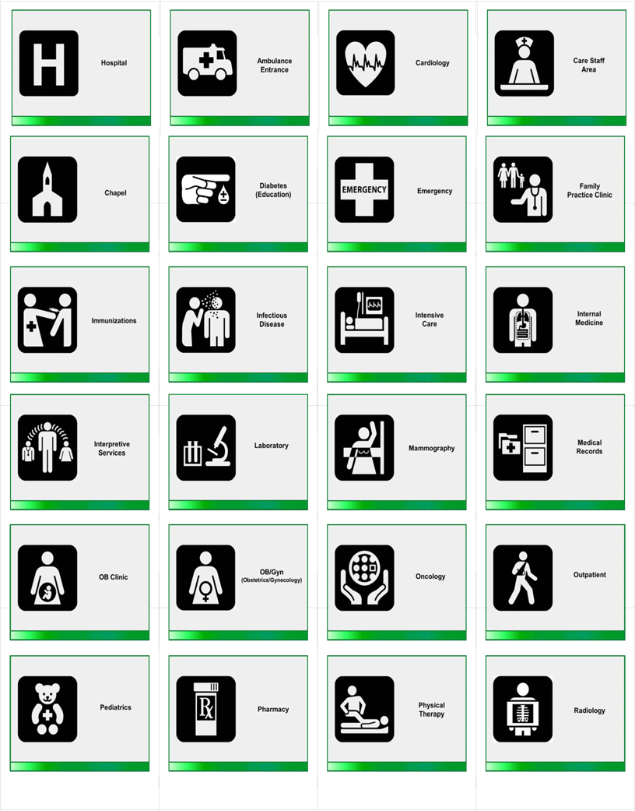

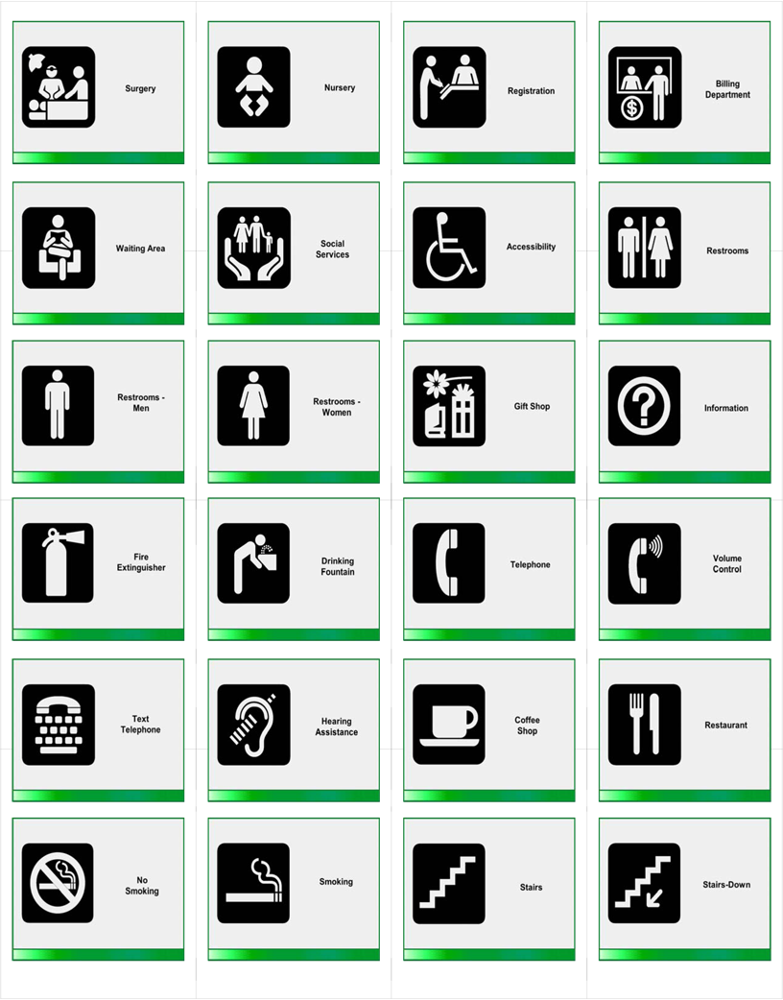

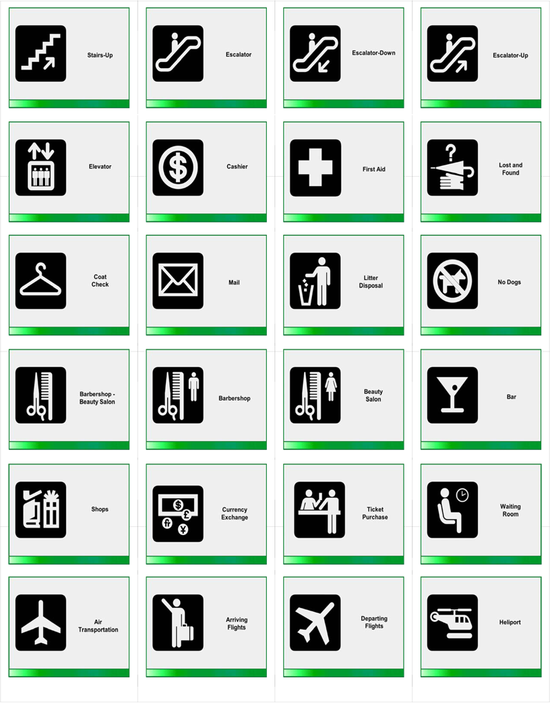

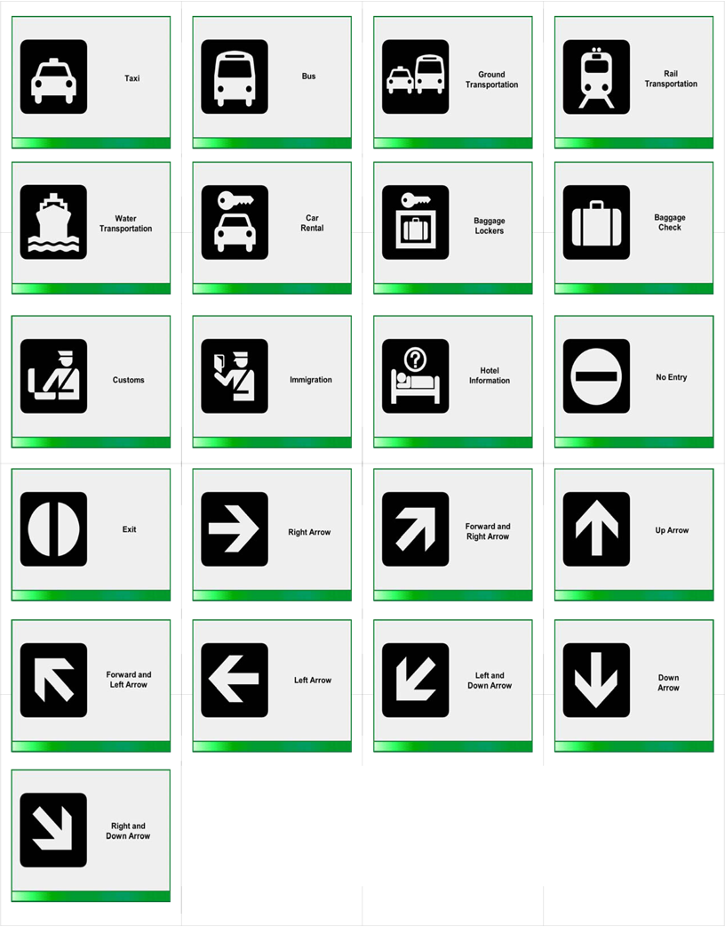

PID
Pelvic inflammatory disease

pigmentation
color

pit and fissure sealant (dental sealant)
thin layer of plastic painted onto teeth to prevent decay

placebo
sugar pill, drug with no active ingredient and will cause no effect

placed
put

placenta
organ that attaches umbilical cord to the inside of the womb

plaque
sticky film with germs on teeth

platelet
blood clotting cell

pleurisy
lung inflammation

pneumonia
lung infection

PO
taken by mouth, eat or drink

podiatry
treating feet problems, medical care for feet, foot doctor

poliomyelitis
polio; a disease that can make you unable to move

pollute
dirty, poison, taint, spoil

polysaccharide vaccines
sugar vaccines

polyurethane
plastic

portion
piece, amount, part, serving

position
job, rank, class, grade

possess
have, own

possibility
chance

posterior teeth
back teeth

post-exposure prophylaxis
drug given to someone who has been near someone sick, prevention drug, drugs to
prevent the spread of disease

post-partum depression
baby blues, overwhelmed, depressed, unexplained sadness after having baby

postpone
put off, wait, delay

potency
strength, force, power, level, dose

precaution
safeguard, caution, guard, care

predicament
problem, bad situation, plight, difficulty

pregnancy
pregnant, expecting a baby

preliminary
early, not final, initial

pre-pandemic vaccine
pandemic flu or deadly flu vaccine; shot

preparedness
readiness, alertness, to be ready, to prepare, be prepared, planned

prepuce
foreskin

prerogative
right, choice

prescriber
doctor, nurse, any medical person who is licensed to write prescriptions

prescription
doctors orders, medicine, drug order,

present
give, send, now, show, here

prevalence
number of sick people, spread, disease spread, number, figure

prevent
stop, keep from happening, forbid, bar, keep

preventive
(i.e.; preventive services) practices that help keep you well

prevention
stop, bar, not permitted, not allowed, to avoid ill effects

primary teeth
baby teeth, first teeth

principal
main, first, head, chief, most important

prior to
before

probability
chance, likelihood

proximal
near to, close, area closer to the center of the body

procedure
steps, method, course of action, how-to, way, test

proceed
go, move forward

prodromal
signs of disease or attack

proficient
skilled, experienced, able, apt

progression
move forward, go on, get worse, advance

prohibit
ban, forbid, prevent

projectile
flying object, fast object, thrown object

proliferate
grow, spread, reproduce

prophylactic
pregnancy prevention drug, sickness prevention drug, birth control, condom

prophylaxis
prevention, protection

prophylaxis (dental, oral)
basic teeth cleaning

prostate
gland in male body that makes semen

prostatitis
infection of the prostate

prosthodontic
treatment using crowns, bridges, partials and/or dentures

protocol
way of doing things, method, standard, step-by-step process, rules, code

provide
give, offer, send, supply

provider
professional, insurer

provoke
make worse, cause, anger, annoy

proximal
near to, close, area closer to the center of the body

psoriasis
a dry, scaly, skin rash

psoriatic arthritis
joint swelling disease with skin rash

psychiatrist
mental health doctor, shrink

psychiatry
study of mental health

PSA
prostate test, prostate check

PTSD
problem with fear after seeing or having a fearful event, flashbacks of negative
experience

public health
everyone’s health, our health, health of the community as a whole

puff
a short, gentle burst; a small breath

pulmonary
related to the lungs

pulmonary cancer
cancer of lung, trachea, bronchus

pulmonary care unit
lung disease treatment area of hospital

pulmonary fibrosis
lung disease, scarring of lung tissue, shortness of breath

pulmonologist
lung doctor

pulmonology
study of lung disease

pulp
tooth nerve

pulpectomy
remove nerve from tooth

pulpitis
infection of nerve inside tooth

pulpotomy
take out the nerve from a tooth

purchase
buy

purulent
pus

pyrexia
fever

Q
qualified
suited, capable; has the education to perform, license to perform

quarantine
isolate, staying away from other people, staying home by yourself

R
RA
rheumatoid arthritis, disease of joints

radiation
energy, rays, waves, heat

radioisotope
medicine, special medicine, drug or radioactive tracer

radiologist
a doctor who studies x-rays and other images, x-ray specialist, x-ray doctor

radiology
x-ray department

radionuclide
medicine, special medicine or drug

rampant
unchecked, raging, uncontrolled

rapid diagnostic test
fast result test, quickly check if someone is sick

rationale
reason, thinking, intent, purpose

Raynaud’s syndrome
circulatory disease

reaction
a response

reassortment
change, new type of virus

receive
get, admit, welcome

receptive language
understanding

recipient
person who gets something

recognize
accept, know, see, find

recombinant
new gene combination

recommend
advise, suggest, urge, says

recover
get better, feel better, heal

recrudescence
relapse, to get sick again

recuperate
get better, feel better, get well, recover

recur
come back, get again, happen again

reduce
lower, cut, trim, dilute

redundant
extra, not needed, excess, surplus, spare

refills
number of times one can get more medicine from the drugstore without going back to
the doctor

reflux
spit up, backward flow of body fluid

regarding
about

regimen
diet, plan, program

register
sign up, sign in
regular
usual, normal, everyday, common

regulate
control, restrict, watch over, govern

regulation
rule, law

rehabilitate
get better, restore

reimburse
pay back, refund

reinforce
make stronger, brace, support

reiterate
repeat, say again

relief
feel better, ease, not as bad, less painful, more comfortable

relieve
ease, make better, soothe, rest

remission
when a disease is not active

renal
related to the kidney

request
ask for, beg

require
need, ask for

requirements
needs, regulations

rescind
cancel, take away

resemble
look like, take after, match

reside
be in, live in

residence
home, apartment, house

Residual Seizure Disorder
seizures, sudden attack, brain problem

respiration
breathing, taking in oxygen

respiratory therapist
breathing therapist

respite
rest, relief, quiet time

respond
answer, react to

restoration
filling, fix a tooth, tooth replacement

restrain
hold back, stop

restrict
limit,stop

restrictions
limitations, changes

retain
keep

retrieve
get, bring back, get back

return
go back

reveal
show, tell

review
go over, check;

Reye’s Syndrome
brain disease in children

rheumatoid arthritis
disease of joints, joint swelling

rheumatologist
joint, bone, and immune system doctor

rheumatology
study of the immune system, joints, and bones

rigorous
hard

risk reduction
lowering the chances, making less likely

risk
chance

root canal
remove the nerve from inside the root of a permanent tooth

root planing and scaling
deep tooth cleaning

Rotavirus
germ causing stomach flu

Rubella
German measles

Rubeola
measles

rupture
break, burst, break open

S
sanitary
clean, germ free, healthful

sanitize
clean, wash, clean up, make germ-free, disinfect

SC
subcutaneously, shot into fat, injection into fat

scaling and root planing
removal of hard and soft deposits from teeth above and below gums

Scarlatina
scarlet fever

schedule
plan, planning a time to do something

sealant (pit and fissure, dental)
thin layer of plastic painted onto teeth to prevent decay

seasonal influenza
common flu; winter flu

second- and third-order effects
things that happen as a result of your actions

sector
group, community, neighborhood

sedentary
inactive, sitting a lot, couch potato

segment
part, piece

seizure
fit of uncontrolled movements

sensation
feeling

sensitive
easily hurt, easy to damage, sore

seroconversion
becoming immune, reacting against disease, fighting disease

serology
study of blood strength

serosurvey
test to see how likely you are to get a disease

several
many

severe
strong, serious, harmful, dangerous, very bad

severity
how bad

shift
change

shortness of breath
difficulty catching breath, difficult breathing

side effect
reaction, reaction to a medicine

significant
big, serious, important

similar
like

situated
placed, located

Sjogren’s syndrome
dry eyes and mouth

skull
head bones, bones that protect the brain

social distancing
stay at home; keep away from people

socialize
make friends, talk with people, meet people

solicit
ask for

soreness
hurt, pain, ache

spasm
sudden, strong muscle tightening, jerk, painful twist

species
group of plants or animals, same type, alike

spirometer
breathing test, breath strength machine, breath strength indicator

spontaneous
unplanned, sudden

sprain
muscle injury, muscle tear

stable
okay, no change, constant, even, unchanging

stamina
strength, endurance

state of readiness
ready, now ready, prepared

state
say, tell, condition

status
state, condition

sterile
unable to have children, clean

steroid
medicine, drug to lessen swelling, illegal sports drugs

stigma
mark, spot, blemish, embarrassment

stimulate
excite, stir up, activate

strain
type of germ, type of animal, type of plant

stress
physical strain, mental strain, pressure, worry

stringent
strict, tight, controlled

subclinical infection
minor illness

submit
give, hand in, send

subsequent
following, next, later

subsequently
after that, later, afterward

substance
chemical, material, matter, stuff

Sudden Infant Death Syndrome (SIDS)
crib death; sudden, unexplained death of a baby

suffice
be enough

sufficient
enough, plenty, ample

suffocate
choke, smother, not able to breathe

summon
call for, request

sun protection factor
sunscreen, sun block

superficial
not important, not harmful, slight

supersede
replace, take the place of

supplement
add to, in addition to, additive, vitamins

supply
give, budget, fund, pool, source, kitty

suppress
hold back, stop, slow down

surge capacity
being able to offer more services in an emergency, ability to expand

surgery
operation

surgical mask
face mask, mask

surveillance
keep a close eye on, watch closely, monitor

susceptible
more open to, in danger of getting, likely to get

sutures
stitches

symptom
sign (of disease or sickness), indicator, warning

syndrome
illness, sickness, condition

synthesis
summary, make, take up

synthesize
combine, form, summarize

systematic
planned out, orderly, regular

Systemic Lupus Erythematosus
immune system disease

systemic
throughout your body, in all parts of your body

T
tallus
heel

taper
reduce, slow, lower, shrink, decrease

tartar
crust on teeth, plaque

telework
work from home

temperature
heat, fever

temporal association
when two things happen at the same time but aren’t actually related to each other

temporary
short, brief

teratogenic
something that can hurt your baby before he is born

terminal
deadly, fatal

terminate
stop, end

testosterone
male hormone

tetanus
disease affecting muscles

therapeutic
healing, improving, getting better

therapy
treatment

therefore
so

thimerosal
drug or vaccine preservative

third molars
wisdom teeth, last teeth to come into mouth

thrombus
clot

time period
time

titer
blood test

titrate
to change the dose/level of a medicine

topical
on the surface, on the skin, on the body

toxicology
study of harmful materials

toxin
poison, pollution

transform
change, alter

transparent
clear, see-through

transpire
happen, take place

transverse myelitis
of the spine, back disease

traumatic
shocking, upsetting

treat
give care, take care of, cure, heal

treatment
action, medicine, therapy

tremor
shaking, trembling

trigger
cause, start, bring on, lead to

trimester
three months, three month’s time

tuberculosis
TB, lung disease

tumor
growth, lump

U
ulcer
open sore, canker

ulterior
secondary, hidden, alternate, further

ultimate
final, last

umbilicus
belly button, navel

underbite
lower teeth extend past upper front teeth

understand
know, to get

unfavorable
bad, harmful, damaging, unwanted

unnecessary
not needed, needless

upper respiratory system
nose, throat, and windpipe

urinate
pee

urticaria
hives, itch, rash on your skin

until such time
until

use caution
be careful

uterus
womb

utilize
use, make use of

UVA
UV light, sunlight

UVB
UV light, sunlight

V
vaccinate
to protect against disease, usually by a shot

Vaccine Adverse Event Reporting System
VAERS, a way for doctors to make sure that vaccines aren’t hurting anyone

Vaccine Safety Datalink Project
VSD, a way for doctors to learn more about vaccines

vaccine
shot, flu shot, medicine, immunization

vague
unclear, not for sure, not certain

validate
prove, test

validity
truth, proof

variant
version, slightly different

Varicella
chicken pox, herpes zoster

variola
smallpox

vary
change, shift

vehicle
car, truck, bus, automobile

verbatim
exact, word for word

verify
check, find out

vesicular
blisters, small bumps on your skin

viable
able to live, usable, can be used

vicinity
area, location

viral shedding
coughing and sneezing

viremia
viruses in the blood

virulence
strength; harm; how harmful; how dangerous the disease is

virulent
strong, dangerous

virus
germ

vital
important, imperative, crucial

voluminous
large, bulky

voluntary
your choice; on your own; without being forced

vomit
throw up, upchuck, emesis

W
waning immunity
not immune any more; more likel to get sick; lost your disease resistance

warning sign
sign of trouble; problem; alert

waterfowl
water birds; birds that live on water; ducks, geese, and swans

wheeze
breathing problem, difficulty breathing; gasp; gag; pant

whereas
while, but

white spot lesion
white spot on tooth, beginning decay

whooping cough
disease of the lungs that is very easily spread to others

withhold
deny, keep from, hold back, refuse

withstand
take, bear, resist

witness
see, note, observe

X
x-ray
picture of your bones; picture of your insides

Y

Z
zoonoses
diseases that people can get from animals; diseases that are passed between animals and people

