Baby Business for parents order form
Submit this completed order form to:
Centre for Community Child Health
Email: ccch.research@mcri.edu.au OR Fax: (03) 9345 5900

Once payment has been processed you will receive an email with a unique code for the
requested amount of books.

Please print clearly in block letters.

Number of  booklets | Quantity | Unit cost inc GST | Postage & handling | Total cost
1- 9 |  | $8.00ea | $9
10- 39 |  | $8.00ea | $15
40- 59 |  | $8.00ea | $30
60- 99 |  | $8.00ea | $40
100- 149 |  | $5.00ea | $50
150- 199 |  | $5.00ea | $60
200- 249 |  | $4.00ea | $75
250- 299 |  | $4.00ea | $100
300- 399 |  | $4.00ea | $120
400- 499 |  | $4.00ea | $135
500- 999 |  | $4.00 | Contact us for a quote
1000 + |  | $3.00ea | Contact us for a quote
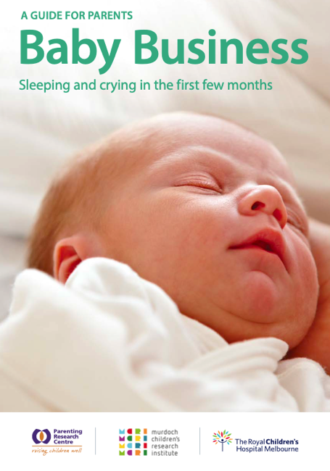

Copies are also available for purchase at the Royal Children’s Hospital Shop

Purchase order no: | (Your organisation’s PO Number)
Name:
Organisation
Phone Number:
Email address:
Address:

Suburb/ Town: |  | State: |  | Postcode:

Payment details
Invoice Credit card (please ensure all details are completed fully)
Card type: MasterCard Visa
Card number: | Expiry date
Name on card:
Signature:

