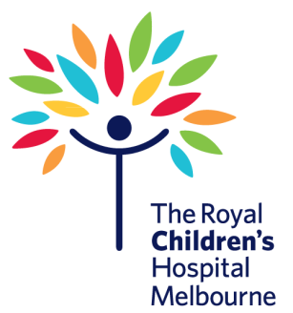
Training Registration
Please complete the details below and forward with payment to: carol.whitehead@rch.org.au
One form per registrant:
Personal Information:
Name:
Address:
Suburb: State: Postcode:
Phone: Mobile:
Email:
School / Children’s Service:
Course: please tick/cross one
□ 22300VIC Course: First Aid Management of Anaphylaxis - $75.00 + GST
Date of training request: Time
Registration Fees: Payment options:
□ Credit card – please ensure all details are completed below
□ please invoice the organisation below
Fill in for credit card payment: □ Mastercard □ Visa
Card Number: _ _ _ _ / _ _ _ _ / _ _ _ _ / _ _ _ _ Expiry date: _ _ / _ _ Signature:
Name:
Organisation:
Mailing address:
Suburb: State: Postcode
Phone: Fax: Email:
Places are limited. Registration is not confirmed until payment is received.
One week’s notice of cancellation of registration is required or a refund cannot be granted.
ABN 35 655 720 546 “The Royal Children’s Hospital”
On payment of this registration, this document becomes a tax invoice

